**Bridge Building:**

**A Game for Teaching the Entrepreneurial Process**

Dr. Robert E. Nelson

Instructor Emeritus and Senior Scholar in Residence

Academy for Entrepreneurial Leadership

University of Illinois, Urbana-Champaign Campus

[renelso@illinois.edu](mailto:renelso@illinois.edu)

Debbi D. Brock

Assistant Instructor of Entrepreneurship & Marketing

Wingate University

[d.brock@wingate.edu](mailto:d.brock@wingate.edu)

**Abstract**

Teams compete to design and construct a model of a bridge using limited resources. This interactive competition requires students to work together in groups to: a) think creatively about designing the bridge, b) agreeing on all aspects of the construction of the bridge and using personal strengths within the team, and c) utilizing marketing techniques to sell the model of the bridge to a wealthy real estate developer.

*Keywords: Entrepreneurial process, entrepreneurship education, creativity, experiential exercises, teamwork and resource constraints*

*Manuscript Subject Area: Entrepreneurship*

*Subject Topic: Design and creative problem solving exercise with resource constraints*

*Student Level: Secondary, undergraduate and graduate students*

*Time Required: Approximately 75 minutes (can be done in 60 minutes)*

*Recommended Number of Students: No more than 50 students (5 to 7 on a team and an observer for each team)*

**Acknowledgments**

This experiential entrepreneurship education activity was developed for use in the Know About Business (KAB) curriculum published by the International Labor Organization (ILO). The KAB curriculum has been introduced in over 40 countries and has been translated into over 20 languages. KAB is intended for use in secondary and university classrooms. Promoting youth entrepreneurship is an important strategy for the ILO in resolving the global unemployment challenge for young job seekers and job creators. For further information, contact the ILO at: [www.knowaboutbusiness.org](http://www.knowaboutbusiness.org) or [www.ilo.org/seed](http://www.ilo.org/seed)

**Game Objective**

The objective of the game is to have teams compete to construct a model bridge using limited resources. The game requires students to work as a team to plan, design, and build the bridge with limited resources. Using experiential learning developed by Kolb (1984), teams must creatively apply entrepreneurial skills to design the bridge, reach agreement on all aspects of construction of the bridge, use the expertise of team members to construct the bridge and utilize marketing techniques to sell the model of the bridge to a wealthy real estate developer. The game can be used to reinforce the Timmons Model of the Entrepreneurial Process.

**Figure 1:**

**Timmons Model of the Entrepreneurial Process**

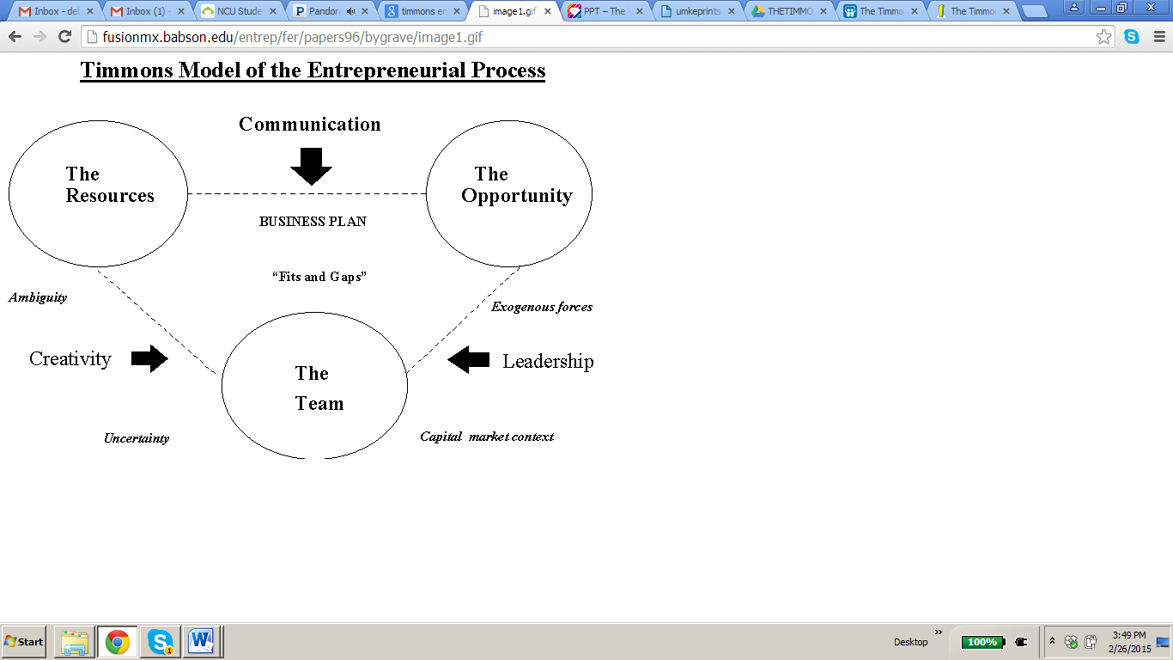

Timmons, J. A. (1985). *New Venture Creation*. Chicago, IL: Tata McGraw-Hill Education.

**Game Design**

Students are divided into teams of 4 to 7. Each team should decide on a name for their team. The instructor states that a very wealthy real estate developer wants to construct a bridge over a river for cars and trucks. Construction firms are being asked to submit designs for a model bridge that would be modern, stunning and amaze people coming into the city. The bridge must be 6 inches high, 12 inches in length and 4 inches wide so boats can pass under the bridge safely.

The bridge should be both aesthetically pleasing, but sturdy enough to support a light weight to be placed on the top of the middle of the bridge. The instructor should have a weight available at the beginning of the game so that the team members can hold the weight to understand how sturdy the bridge needs to be designed to hold the weight. Students are informed of the scoring criteria to determine the winner of the contract to construct the bridge. The criteria are as follows:

**Evaluation Criteria**

* **Design**: Original design of bridge (compared to finished product) 20 points
* **Quality**: Construction sturdiness (weight on top of middle of bridge). 20 points
* **Production Accuracy**: Correct height, width, length of the bridge 20 points
* **Resource Management**: Efficient/effective use of materials 20 points
* **Presentation**: Marketing presentation on quality, benefits, and design 20 points

At the start of class, pass out the Request for Proposal in Appendix A to each of the teams and discuss each of the criteria. Teams might elect one of their members to take a leadership role. Remind the students if the bridge is not sturdy, it may collapse during the evaluation when a weight is put on the middle of the bridge.

One or two students should be designated as Team Observers for each team. They would use the Observer Form in Appendix B to write comments regarding the actions and performance of the team members during the playing of the game.

**Resource Mobilization**

Teams are given 10-15 minutes to design a bridge on a piece of paper (give more time if needed). Each team is then provided with the same amount of building materials. Each team is provided four feet of scotch tape to use in constructing the bridge. Teams need to be very economical in using the tape. Additional tape may be provided to all the teams (at the discretion of the instructor).

**Building Supplies**

Materials to build the bridge include: used plastic water bottles, old newspapers and magazines, used paper, sticks, stones, etc. Each team should have the exact same amount of materials.

**Building Construction**

The teams have 30 to 40 minutes to construct their bridge. The teams may work in different parts of the room to hide the bridge design features from competitors. If needed, additional time for constructing the bridge may be granted by the instructor.

**Marketing Pitch**

Each team will have 3 minutes to make a marketing “elevator pitch” to the class and the instructor as to why their bridge should be selected.

**Judging**

To avoid any perceived bias, another instructor or a departmental staff member might serve as the judge for evaluating the bridge design and construction. The judge should be present during the bridge building and observe the entire game. For “measurement” purposes, the judge would need a tape measure and a weight that can be placed on the bridge to determine its durability. After evaluating all the bridges, the judge should give favorable comments about each bridge. The instructor would then announce the third place, second place and the first place winners.

**Debriefing on Learning Points**

The instructor would ask the team Observers to come to the front of the room and have a general discussion of the performance of the teams using their responses to the questions in Appendix B. There are two key learning objectives of this activity that should be reinforced. The first objective is to highlight the entrepreneurial process and importance of teamwork to an entrepreneurial organization. From the identification of an opportunity (market opportunity that created the need for the bridge) to teamwork (leadership, team building, and decision-making), and mobilization of resources (materials, uncertainty, competitive actions, ability to adapt, and change), the team was able to utilize the entrepreneurial process during the game. The instructor can write the main elements of the Timmons model on the board during the discussion to reinforce the model.

Second, most business activities take place within an organization. As Timmons stated, a critical ingredient for success in entrepreneurship is the entrepreneurial team (1985). Entrepreneurial leaders learn from others; they teach, adapt and change. The team leader needs to adapt to change and deal with adversity. The team must be persistence to accomplish the task of building the bridge and determined to pursue their proposed entrepreneurial venture.

**Student Reactions**

This activity has been done with undergraduate students, secondary students and faculty in Uganda, Ethiopia, and the United States. The feedback from the bridge building game includes the following:

* The limited time to construct the bridge put pressure on the teams to complete the task with the limited resources available.
* Your final product may not be what you originally designed it to be.
* Students learned to cope with stresses and meeting deadlines.
* Like a business, the tasks of constructing a bridge were divided among the team members.
* The game shows that team problem solving is much more effective than individual problem solving.
* Quick decisions had to be made during the game. The teams could see the results of their decisions and make changes when needed.
* Teams implemented their own meaning of creativity.
* “Wow.” My team came up with a bad design.
* The game provided many learning points related to entrepreneurship concepts previously learned and that increased the instructional value of playing the game.
* I am definitely not going to be a bridge builder.
* Teams were able to use the entrepreneurial process to achieve their goals.

**Appendix A:**

Request for Proposal: Bridge Building & Design

The objective of the game is to enable students to demonstrate entrepreneurial skills such as: innovative solutions, creativity, resource mobilization, and teamwork necessary to accomplish a group task. The challenge is to construct a model of a bridge using limited resources. The group needs to creatively apply skills to design the bridge, reach agreement on all aspects of the construction of the bridge, use individual personal strengths to construct the best bridge possible and utilize marketing techniques to sell the model of the bridge to a wealthy real estate developer.

**Design Criteria.** The area under the bridge must be 6 inches high, 12 inches in length, and 4 inches wide so boats can pass under the bridge safely. The bridge should be both aesthetically pleasing, but sturdy enough to support a weight to be placed on the top of the middle of the bridge. The bridge construction will be evaluated based on the five criteria below.

|  |  |  |  |  |  |  |
| --- | --- | --- | --- | --- | --- | --- |
| Team Members: | RATING (1to 20)*  1=poor ---- 20=excellent | | | | | COMMENTS |
| BRIDGE BUILDING CRITERIA  <20 points> | 1 | 5 | 10 | 15 | 20 |  |
| Design: Original bridge design and attractiveness (compared to finished product) |  |  |  |  |  |  |
| **Quality:** Construction sturdiness, ability to handle the weight. |  |  |  |  |  |  |
| **Production Accuracy**: Accurate height, width, length of the bridge specifications. |  |  |  |  |  |  |
| **Resource Mobilization**: Efficient and effective use of resources and materials |  |  |  |  |  |  |
| **Presentation**: Marketing presentation to client about the quality, benefits, and design of the bridge (limit 5 minutes) |  |  |  |  |  |  |
| OVERALL COMMENTS ON PROJECT | Overall Score | | | |  | |
|  | | | | | | |

Appendix B:

Observer Form

During the playing of the game, your task is to record your observations of the team as they are in the process of designing and constructing the bridge. These observations might include the following:

Teamwork

* How did the team divide the tasks and why was teamwork an important part of this activity?
* How was the team leader determined and did the team work effectively with the team leader throughout the process?
* To what extent did all the team members contribute equally to the task and how would you rate the ability of the members to work as a team?

Innovative Design and Problem Solving

* How did the team handle problems related to the design and construction of the bridge?
* If you were part of the team, in what ways would you have improved the design and construction of the bridge?
* In what ways was the team innovative and creative while playing this game?

Resource Mobilization

* To what extent were the construction resources (tape, paper, etc.) used efficiently and how well did the team operate with the resource constraints?

Elevator Pitch

* How did the team prepare for the marketing elevator presentation and why is the ability to communicate critical to marketing elevator pitch presentation?

Entrepreneurial Process

* In what specific ways was this game an example of the entrepreneurial process?

**References**

Kolb, D. A. (1984). *Experiential learning: Experience as the source of learning and development*. *1*. Englewood Cliffs, NJ: Prentice-Hall.

Timmons, J. A. (1985). *New Venture Creation*. Chicago, IL: Tata McGraw-Hill Education.

**Title:** Bridge Building: A Game for Teaching the Entrepreneurial Process

**Learning Outcome:**

Design and construct a model of a bridge using limited resources

**Process:**

Game Design   
Students are divided into teams of 4 to 7. Each team should decide on a name for their team. The instructor states that a very wealthy real estate developer wants to construct a bridge over a river for cars and trucks. Construction firms are being asked to submit designs for a model bridge that would be modern, stunning and amaze people coming into the city. The bridge must be 6 inches high, 12 inches in length and 4 inches wide so boats can pass under the bridge safely.   
The bridge should be both aesthetically pleasing, but sturdy enough to support a light weight to be placed on the top of the middle of the bridge. The instructor should have a weight available at the beginning of the game so that the team members can hold the weight to understand how sturdy the bridge needs to be designed to hold the weight. Students are informed of the scoring criteria to determine the winner of the contract to construct the bridge. The criteria are as follows:

Evaluation Criteria

• Design: Original design of bridge (compared to finished product) 20 points   
• Quality: Construction sturdiness (weight on top of middle of bridge). 20 points   
• Production Accuracy: Correct height, width, length of the bridge 20 points   
• Resource Management: Efficient/effective use of materials 20 points   
• Presentation: Marketing presentation on quality, benefits, and design 20 points

At the start of class, pass out the Request for Proposal in Appendix A to each of the teams and discuss each of the criteria. Teams might elect one of their members to take a leadership role. Remind the students if the bridge is not sturdy, it may collapse during the evaluation when a weight is put on the middle of the bridge.   
One or two students should be designated as Team Observers for each team. They would use the Observer Form in Appendix B to write comments regarding the actions and performance of the team members during the playing of the game.

Resource Mobilization   
Teams are given 10-15 minutes to design a bridge on a piece of paper (give more time if needed). Each team is then provided with the same amount of building materials. Each team is provided four feet of scotch tape to use in constructing the bridge. Teams need to be very economical in using the tape. Additional tape may be provided to all the teams (at the discretion of the instructor).

Building Supplies   
Materials to build the bridge include: used plastic water bottles, old newspapers and magazines, used paper, sticks, stones, etc. Each team should have the exact same amount of materials.

Building Construction   
The teams have 30 to 40 minutes to construct their bridge. The teams may work in different parts of the room to hide the bridge design features from competitors. If needed, additional time for constructing the bridge may be granted by the instructor.

Marketing Pitch   
Each team will have 3 minutes to make a marketing “elevator pitch” to the class and the instructor as to why their bridge should be selected.

Judging   
To avoid any perceived bias, another instructor or a departmental staff member might serve as the judge for evaluating the bridge design and construction. The judge should be present during the bridge building and observe the entire game. For “measurement” purposes, the judge would need a tape measure and a weight that can be placed on the bridge to determine its durability. After evaluating all the bridges, the judge should give favorable comments about each bridge. The instructor would then announce the third place, second place and the first place winners.

Debriefing on Learning Points   
The instructor would ask the team Observers to come to the front of the room and have a general discussion of the performance of the teams using their responses to the questions in Appendix B. There are two key learning objectives of this activity that should be reinforced. The first objective is to highlight the entrepreneurial process and importance of teamwork to an entrepreneurial organization. From the identification of an opportunity (market opportunity that created the need for the bridge) to teamwork (leadership, team building, and decision-making), and mobilization of resources (materials, uncertainty, competitive actions, ability to adapt, and change), the team was able to utilize the entrepreneurial process during the game. The instructor can write the main elements of the Timmons model on the board during the discussion to reinforce the model.   
Second, most business activities take place within an organization. As Timmons stated, a critical ingredient for success in entrepreneurship is the entrepreneurial team (1985). Entrepreneurial leaders learn from others; they teach, adapt and change. The team leader needs to adapt to change and deal with adversity. The team must be persistence to accomplish the task of building the bridge and determined to pursue their proposed entrepreneurial venture.

**Tips:**

Game Objective   
The objective of the game is to have teams compete to construct a model bridge using limited resources. The game requires students to work as a team to plan, design, and build the bridge with limited resources. Using experiential learning developed by Kolb (1984), teams must creatively apply entrepreneurial skills to design the bridge, reach agreement on all aspects of construction of the bridge, use the expertise of team members to construct the bridge and utilize marketing techniques to sell the model of the bridge to a wealthy real estate developer. The game can be used to reinforce the Timmons Model of the Entrepreneurial Process.

**Categories:** Ideation  
Creativity